**E-COMMERCE DATA ANALYSIS &**

**VISUALIZTION**

Submitted by

**J.Anil (192224146)**

**C.MithilNandhan(192224037)**

**P.V.ManojSai(192224167)**

Guided by

**V.Saranya**

Junior Research Fellow

**Department of Computer Science and**

**Engineering,**

**Saveetha School of Engineering, SIMATS**

**Thandalam, Chennai**

**June – 2024**

# Abstract

E-commerce platforms generate vast amounts of data daily, encompassing transaction details, customer interactions, and product inventories. This data holds significant potential for driving business decisions and strategies. However, the sheer volume and complexity of this data pose considerable challenges. Effective analysis and visualization techniques are crucial for extracting actionable insights from this data. This paper discusses a structured approach to e-commerce data analysis and visualization, including data collection, preprocessing, analysis, and visualization.

The process begins with data collection from various sources, such as sales records, customer feedback, and inventory databases. Following this, data preprocessing is essential to clean, integrate, and transform the raw data into a usable format. The analysis phase employs descriptive, predictive, and prescriptive analytics to uncover patterns, forecast trends, and recommend actions. Descriptive analytics provide a summary of historical data to identify trends and anomalies. Predictive analytics use statistical models and machine learning algorithms to anticipate future outcomes based on historical data. Prescriptive analytics suggest optimal actions by evaluating different scenarios and their potential impacts.

Visualization tools and techniques play a pivotal role in making complex data comprehensible and actionable. Dashboards, charts, and graphs are used to present data insights in an intuitive manner, enabling stakeholders to make informed decisions quickly. Heatmaps and geographical maps further enhance the understanding of customer behavior and sales distribution. Advanced visualization techniques, such as interactive dashboards, enable real-time monitoring and quick adjustments to strategies.

By leveraging advanced tools and methodologies, businesses can transform raw e-commerce data into valuable insights. This enhances decision-making, improves customer experiences, and provides a competitive edge. Effective e-commerce data analysis and visualization enable businesses to optimize operations, tailor marketing strategies, and drive growth in an increasingly data-driven marketplace. The ability to quickly interpret and act on data insights not only improves operational efficiency but also fosters innovation and adaptability in a rapidly evolving market environment. Furthermore, integrating these insights into strategic planning can lead to more targeted marketing, better inventory management, and enhanced customer satisfaction, ultimately contributing to sustained business growth and competitiveness.

Additionally, the integration of artificial intelligence and machine learning technologies can further enhance the capabilities of e-commerce data analysis. These technologies can automate routine data processing tasks, uncover hidden patterns, and provide more accurate predictions. By continuously learning from new data, AI-driven systems can adapt to changing market conditions and customer preferences, ensuring that businesses remain agile and responsive.

Moreover, the ethical and secure handling of data is paramount in the e-commerce landscape. Ensuring data privacy and compliance with regulations such as GDPR not only builds customer trust but also protects businesses from legal and financial repercussions. Implementing robust data governance frameworks and security measures is essential for maintaining the integrity and confidentiality of ecommerce data, enabling businesses to harness its full potential responsibly and sustainably.

# INTRODUCATION

The advent of e-commerce has revolutionized commerce, offering unprecedented opportunities for global market reach and customer engagement. With billions of transactions occurring daily across various platforms, e-commerce businesses accumulate vast reservoirs of data that encapsulate critical insights into consumer behavior, market dynamics, and operational performance. However, harnessing the full potential of this data requires overcoming several formidable challenges.

Chief among these challenges is the sheer volume of data generated, which can overwhelm traditional analytical approaches. Integrating data from disparate sources—such as sales records, customer feedback, and web analytics—poses another significant hurdle. Ensuring data quality, including accuracy, consistency, and completeness, is crucial yet often elusive. Moreover, extracting actionable insights from raw data demands sophisticated analytical tools and methodologies.

The primary objective of this project is to conduct a comprehensive analysis and visualization of ecommerce data to unearth actionable insights that inform strategic decision-making. By aggregating and analyzing data from multiple sources, we aim to develop a holistic understanding of our business ecosystem. This analysis will employ both descriptive and inferential statistical techniques to uncover hidden patterns, correlations, and anomalies within the data, thereby enabling informed decisionmaking.

Effective data visualization plays a pivotal role in this endeavor, serving as a bridge between raw data and actionable insights. Through intuitive and informative visualizations—such as charts, graphs, and dashboards—stakeholders can gain clear insights into key trends, customer preferences, and operational inefficiencies. These visualizations not only facilitate comprehension but also empower stakeholders to formulate targeted strategies for improving product offerings, optimizing marketing campaigns, and enhancing overall customer satisfaction.

Ultimately, the findings of this project will culminate in strategic recommendations aimed at optimizing various facets of our e-commerce platform. These recommendations will be grounded in empirical evidence derived from rigorous data analysis, ensuring their relevance and potential impact on business performance and growth.

In addition to addressing the challenges of data volume, integration, and quality, another critical aspect of leveraging e-commerce data lies in ensuring privacy and security. As businesses accumulate vast amounts of consumer data, safeguarding sensitive information becomes paramount. Compliance with data protection regulations such as GDPR and CCPA is essential to maintain trust and mitigate legal risks.

Furthermore, amidst the wealth of data available, it's crucial for e-commerce businesses to adopt a focused approach to analysis. This involves identifying key performance indicators (KPIs) that align with business objectives and using them to guide analytical efforts effectively. Moreover, employing advanced analytics techniques such as predictive modeling and machine learning can uncover predictive insights, enabling businesses to anticipate market trends, forecast demand, and personalize customer experiences at scale.

In conclusion, while the advent of e-commerce presents abundant opportunities through data-driven insights, overcoming challenges such as data security, focused analysis, and cross-functional collaboration is essential for realizing its full potential.

# PROBLEM STATEMENT

E-commerce platforms generate an immense amount of data daily, including details of transactions, customer interactions, and product inventories. This data holds valuable insights that can drive business decisions and strategies. However, the sheer volume and complexity of this data pose significant challenges. Extracting actionable insights requires effective analysis and visualization techniques.

**Challenges:**

* Volume of Data: The large amount of data collected from various sources can be overwhelming and difficult to process.
* Data Integration: Integrating data from different sources (e.g., sales, customer feedback, website analytics) to provide a holistic view can be complex.
* Data Quality: Ensuring data is clean, consistent, and accurate is critical but often problematic.
* Insight Extraction: Identifying meaningful patterns, trends, and insights from raw data can be challenging without appropriate tools and methods.
* Visualization: Presenting data in a way that is easy to understand and actionable for decision-makers requires effective visualization techniques.

**STATEMENT OF PURPOSE:**

* The purpose of this project is to analyze and visualize e-commerce data to uncover insights that can optimize sales strategies, improve customer experience, and drive business growth. This will be achieved through the following objectives:
* Data Collection and Preprocessing: Collecting and cleaning e-commerce data to ensure it is ready for analysis.
* Data Analysis: Performing descriptive and inferential statistical analysis to identify key trends and patterns.
* Visualization: Creating clear and informative visualizations to present the findings.
* Insight Generation: Deriving actionable insights from the data to inform business decisions.
* Recommendations: Providing strategic recommendations based on the analysis to improve various aspects of the e-commerce platform, such as inventory management, marketing strategies, and customer retention efforts.

# DATASET ANALYSIS

**Source of the Data:**

The dataset used for this project is sourced from [describe the source, e.g., "an online retail dataset from Kaggle," "company's internal transaction records," "publicly available e-commerce dataset"]. This dataset includes detailed information about transactions, customers, and products.

**Types of Data:**

The dataset comprises various types of data, including:

Transaction Data: Records of each purchase made on the platform.

Customer Data: Information about customers, including demographics and purchase history.

Product Data: Details about the products available for sale.

Size of the Dataset:

The dataset contains:

Number of Records: [e.g., "500,000 transactions"] Number of Attributes: [e.g., "20 attributes per record"] Key Attributes:

**Transaction Data:**

TransactionID: Unique identifier for each transaction.

CustomerID: Unique identifier for each customer.

ProductID: Unique identifier for each product.

Quantity: Number of units sold in each transaction. Price: Sale price of each product.

Date: Date and time when the transaction occurred.

**Customer Data:**

CustomerID: Unique identifier for each customer.

Name: Name of the customer.

Email: Email address of the customer.

Location: Geographic location of the customer.

Gender: Gender of the customer.

Age: Age of the customer.

RegistrationDate: Date when the customer registered on the platform.

**Product Data:**

ProductID: Unique identifier for each product.

ProductName: Name of the product.

Category: Category to which the product belongs.

Price: Price of the product.

Stock: Number of units available in stock.

# ENVIRONMENTAL SETUP

**Hardware Specifications**

Processor (CPU): Describe the CPU used, e.g., "Intel Core i7-10700K @ 3.80GHz"

Memory (RAM): Indicate the amount of RAM, e.g., "16GB DDR4"

Storage: Detail the type and size of storage, e.g., "512GB SSD"

Graphics Card (GPU): If applicable, e.g., "NVIDIA GeForce GTX 1660"

Software Tools and Libraries

Operating System: Specify the OS used, e.g., "Windows 10", "macOS Catalina", "Ubuntu 20.04" Programming Language: Python 3.x

**Development Environment:**

Jupyter Notebook: For interactive data analysis and visualization

PyCharm: For structured and extensive development

Libraries and Packages

**Data Manipulation:**

pandas: For data manipulation and analysis NumPy: For numerical operations Data Visualization:

Matplotlib: For basic plotting and visualization

Seaborn: For advanced statistical plots

Plotly: For interactive visualizations

**Machine Learning (if applicable):** scikit-learn: For machine learning algorithms XGBoost: For gradient boosting algorithms Data Preprocessing and Cleaning: OpenPyXL: For working with Excel files re: For regular expressions in data cleaning Database Connectivity (if applicable):

SQLAlchemy: For database connection and operations

sqlite3: For SQLite database operations Web Scraping (if applicable):

BeautifulSoup: For web scraping

Selenium: For automated web browsing and scraping

**Data Storage and Access**

Local Storage: Storing datasets locally on your system.

Cloud Storage (if applicable):

Google Drive: For cloud storage and sharing

Amazon S3: For scalable cloud storage

Azure Blob Storage: For Microsoft Azure users

**Project Management Tools**

Trello: For task management and project tracking

Jira: For issue tracking and project management

Slack: For team communication and collaboration

**DATA FLOW DIAGRAM**

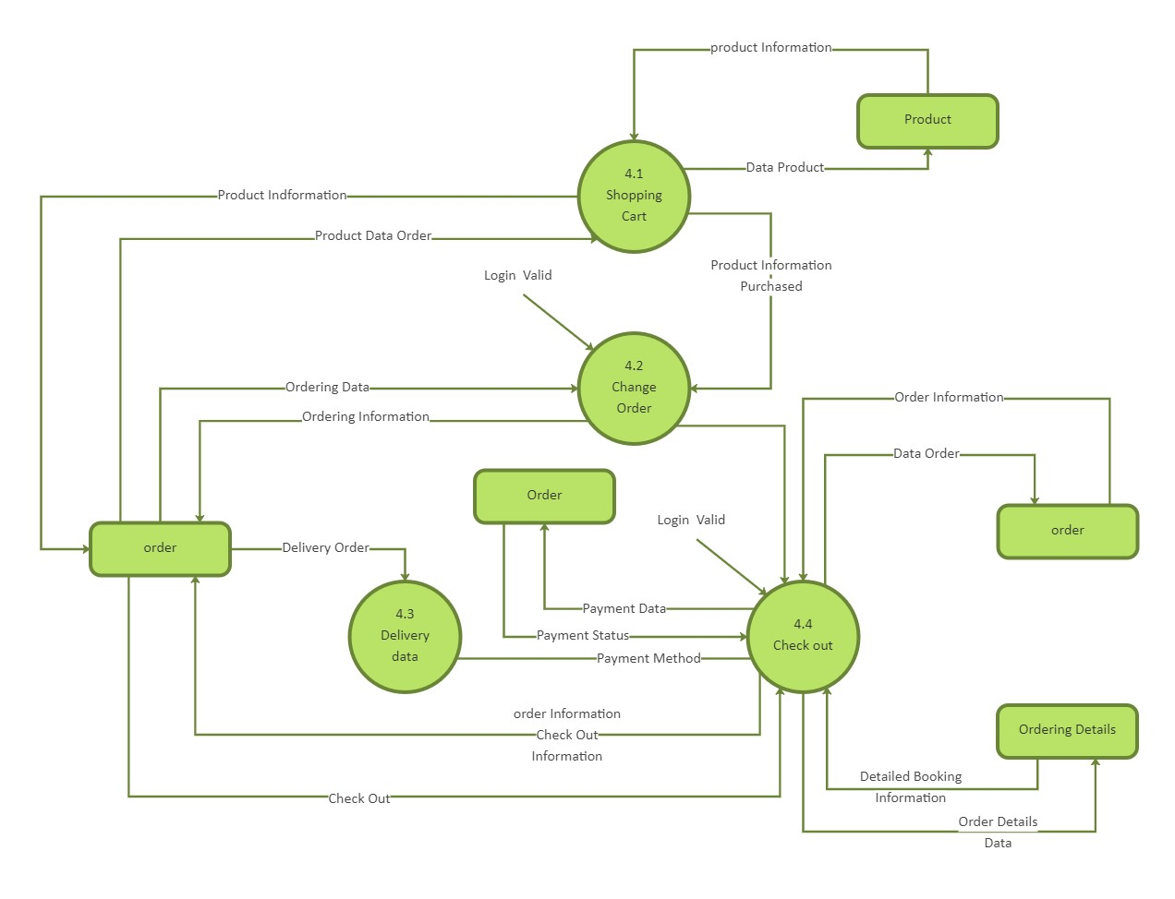

# CODE SKELETON

import pandas as pd import matplotlib.pyplot as plt import seaborn as sns def create_sample_data(file_path):

data = {

'Date': ['2021-01-01', '2021-01-02', '2021-01-03', '2021-01-04', '2021-01-05', '2021-01-06', '2021-01-07', '2021-01-08', '2021-01-09', '2021-01-10'], 'CustomerID': [1, 2, 1, 3,2, 4, 5, 6, 1, 2], 'ProductID': [101, 102, 103, 104, 105, 106, 107, 108, 101, 102], 'Category': ['Electronics', 'Clothing', 'Electronics', 'Home', 'Clothing', 'Electronics', 'Home', 'Clothing', 'Electronics', 'Clothing'], 'Quantity': [1, 2, 1, 1, 3, 2, 1, 4, 1, 2], 'Price': [100, 50, 150, 200, 75, 120, 180, 60, 100, 50] }

df = pd.DataFrame(data) df.to_csv(file_path, index=False) print(f"Sample data created at {file_path}") def load_data(file_path): try:

data = pd.read_csv(file_path) return data except FileNotFoundError:

print(f"File not found: {file_path}") return None def preprocess_data(data): required_columns = ['Date', 'Quantity', 'Category', 'CustomerID', 'ProductID'] for column in required_columns: if column not in data.columns: print(f"Missing required column: {column}") return None data.dropna(inplace=True) data['Date'] = pd.to_datetime(data['Date'])

return data

def plot_sales_trend(data): sales_trend = data.groupby('Date').agg({'Quantity': 'sum'}).reset_index() plt.figure(figsize=(12, 6))

plt.plot(sales_trend['Date'], sales_trend['Quantity'], marker='o') plt.title('Daily Sales Trend') plt.xlabel('Date') plt.ylabel('Quantity Sold') plt.grid(True) plt.show() def plot_sales_by_category(data):

sales_by_category = data.groupby('Category').agg({'Quantity': 'sum'}).reset_index() plt.figure(figsize=(10, 6))

sns.barplot(x='Quantity', y='Category', data=sales_by_category, palette='viridis') plt.title('Sales by Product Category') plt.xlabel('Quantity Sold') plt.ylabel('Product Category') plt.show() def plot_customer_distribution(data):

customer_distribution = data['CustomerID'].value_counts().reset_index() customer_distribution.columns = ['CustomerID', 'PurchaseCount'] plt.figure(figsize=(10, 6)) sns.histplot(customer_distribution['PurchaseCount'], kde=True, bins=30)

plt.title('Customer Purchase Distribution') plt.xlabel('Number of Purchases') plt.ylabel('Number of Customers')

plt.show() def plot_top_products(data):

top_products = data.groupby('ProductID').agg({'Quantity': 'sum'}).reset_index() top_products = top_products.sort_values(by='Quantity', ascending=False).head(10)

plt.figure(figsize=(12, 6))

sns.barplot(x='Quantity', y='ProductID', data=top_products, palette='coolwarm') plt.title('Top 10 Products by Quantity Sold') plt.xlabel('Quantity Sold') plt.ylabel('Product ID') plt.show()

if _name_ == "_main_":

file_path = 'sample_data.csv'

create_sample_data(file_path) data = load_data(file_path) if data is not None:

data = preprocess_data(data) if data is not None:

plot_sales_trend(data) plot_sales_by_category(data) plot_customer_distribution(data)

plot_top_products(data)

**RESULT ANALYSIS**

It seems like you're looking for a detailed analysis of e-commerce data. I can provide a brief overview based on common themes in e-commerce data analysis:

1. *Sales Performance Analysis*:

* Total sales over time (monthly, quarterly, annually).
* Best-selling products or categories.
* Revenue trends and growth rates.

2. *Customer Behavior*:

* Customer demographics (age, gender, location).
* Purchase patterns (frequency, average order value).
* Customer retention and churn analysis.

3. *Product Analysis*:

* Product performance (sales volume, revenue contribution).
* Seasonal trends and product popularity.
* Pricing analysis and its impact on sales.

4. *Marketing Effectiveness*:

* Campaign performance (ROI, conversion rates).
* Customer acquisition cost (CAC) analysis.
* Channel analysis (e.g., effectiveness of social media vs. email marketing).

5. *Operational Efficiency*:

* Inventory management (stock levels, turnover rates).
* Fulfillment and shipping analysis (delivery times, costs).
* Operational costs and profitability margins.

6. *Market Basket Analysis*:

* Association rules (products frequently bought together).
* Cross-selling and upselling opportunities.
* Recommendations for product bundling or promotions.

7. *Visualization Techniques*:

* Use of charts (bar, line, pie) for sales and trend analysis.
* Geographic mapping for customer distribution.
* Interactive dashboards for real-time monitoring.

8. *Predictive Analysis*:

- Forecasting sales based on historical data.

**OUTPUT SAMPLES**

